**IBScanUltimate Windows Mobile Getting Started Guide**

**Version 1.8.4 (April 10, 2015)**

**Copyright @2011-2015, lntegrated Biometrics LLC. All Rights Reserved**



Table of Contents

Revision History 2

1. SDK Contents 3

1.1. Packages 3

1.2. Scanner Model Support 3

1.3. Programming Language Support 3

1.4. Further Information 3

2. Installation Guides 4

2.1. Windows Mobile 6 Installation Guide 4

2.1.1. Overview 4

2.1.2. Installing the SDKs 4

2.1.3. WM SDK Contents 5

2.1.4. Running the pre-compiled IB Simple Scan WM Sample 5

2.1.5. Pre-requisites for using the Windows Mobile IBScanUltimate SDK. 6

2.1.6. Building the IBSU Simple Scan WM sample application 6

2.1.7. Installing the IBScanUltimate Device Drivers and DLLs 7

# Revision History

|  |  |  |
| --- | --- | --- |
| Date | Author | Remarks |
| 2013/10 | Jeff | Created from the standard Getting Started Guide. |

# SDK Contents

## Packages

The Windows Mobile SDK is an-add on package for using with the 32 bit Windows or 64 bit Windows IBScanUltimate SDK.

IBScanUltimate_WM6_x.y.z.zip is the file set for all Windows platforms, where “x.y.z” is the version number such as 1.7.3.

## Scanner Model Support

IBScanUltimate for Windows Mobile supports only the Colombo fingerprint scanner at this time.

For summary information on the Colombo scanner see the “IBScanUltimate Getting Started Guide”.

## Programming Language Support

The IBScanUltimate SDK for Windows Mobile only supports the C/C++ API.

## Further Information

For more information about the C/C++ API of the IBScanUltimate library, please refer to *IBScanUltimate API Manual For C.pdf* and IBScanUltimate API Manual for C on Windows Mobile.pdf.

For the version history of IBScanUltimate, please refer to *IBScanUltimate Version History.pdf*.

For more information about a scanner model, please refer to its hardware manual.

# Installation Guides

Each of the following sections steps through the installation procedure on one platform and summarizes the contents that will be installed with the SDK.

## Windows Mobile 6 Installation Guide

### Overview

The general install process is to install the IBScanUltimate Windows SDK then copy the IBScanUltimate Windows Mobile SDK into the same file tree.

However, at this time the IBScanUltimate Windows SDK and IBScanUltimate Windows Mobile SDK require different versions of the IBScanUltimateApi.h header file. So you may either overwrite the Windows version or create a second file tree to copy the Windows Mobile files into. Creating a second file tree allows you to build both Windows and Windows Mobile scanner applications on the same computer. This is the recommended configuration. Following these directions will create these two file trees.

It is anticipated that future the SDKs will merge this file so that two file trees are unnecessary.

### Installing the SDKs

Install the Windows SDK first:

Execute (usually by double-clicking) the Windows installer, which will be

*IBScanUltimate SDK Setup x.y.z.exe*

for the 32-bit content and

*IBScanUltimate(x64)* *SDK Setup.x.y.z.exe*

for the 64-bit content. Progress through the automatic installer; we recommend accepting default values whenever prompted.

Unzip the Windows Mobile SDK

Unzip IBScanUltimate_WM6_x.y.z.zip to the location of your choice.

Create a copy of the Windows SDK

Locate the SDK files installed. Typically this is one of these locations:

C:\Program Files\Integrated Biometrics\IBScanUltimateSDK_x64

C:\Program Files\Integrated Biometrics\IBScanUltimateSDK

C:\Program Files (x86)\Integrated Biometrics\IBScanUltimateSDK

Create a copy of this directory add “ _WM” to the end of the name.

Copy the Windows Mobile SDK directory on top of the Windows SDK copy

This will add the Windows Mobile specific files to the Windows version of the SDK and overwrite the file IBScanUltimateApi.h.

### WM SDK Contents

The SDK contains the library and sample application needed to start developing a Windows application that interfaces with an IB scanner. The material is separated into several directories, including the following:

* The */Bin/WM6* directory contains the Windows Mobile 6 compiled sample application (IBSimpleScanWM.exe) and a cab file that installs it (SimpleScanWMInstall.cab).
* The */Driver/WM6* directory contains the Windows Mobile 6 driver for the Colombo scanner (CEUSBKWrapperDrv.dll) and a cab that installs it. This will require installation with the correct registry settings on the WM device. This directory also contains the source code for the drivers released under the GNU lessor general public license.
* The */Include* directory contains the include files for the C interface of IBScanUltimate. Warning: As of version 1.7.2 these files overwrite the IBScanUltimate Windows SDK files, but are not identical to them.
* The */Lib/WM6* directory contains the compiled IBScanUltimate library file for linking the Windows Mobile 6 version (IBScanUlatimate_WM6.lib).
* The */WM6 Sample sources* directory contains the source for the sample applications. The applications are separated by language.

### Running the pre-compiled IB Simple Scan WM Sample

This application is a basic example for Windows Mobile using C/C++

Installing IB Simple Scan WM:

1. Copy SimpleScanWMInstall.cab to Intermec CN70 either through a SDCard or active sync.
2. On the Intermec CN70 open file explorer
3. Navigate to the folder you stored SimpleScanWMInstall.cab
4. Click on SimpleScanWMInstall.cab
5. When prompted select install to “Device”
6. Click “Install”
7. You should see the message “SimpleScanWMInstall.CAB was successfully installed on your device”
8. Click “OK”

Running IB Simple Scan WM:

1. In File Explorer navigate to “My Device\Program Files\IB”
2. Tap IBSimpleScan.exe
3. Wait for title screen to automatically close.
4. Click “Start”
5. Initialization will take approximately 2 seconds when you use IBSU_OpenDeviceEx()
6. Place a finger on the Columbo scanner.
7. Fingerprint image will be automatically captured
8. If desired, place another finger on the sensor and press “Start”.
9. When all of the desired prints have been scanned press “OK”
10. To see the stored fingerprints use file explorer and navigate to “My Device\My Documents\My Pictures”. The images will be stored under the date and time that the image was captured. Note it may be necessary use the “Menu->Refresh” menu item to see the most recent finger print captures.

### Pre-requisites for using the Windows Mobile IBScanUltimate SDK.

The following must be installed on the computer used to build applications using the Windows Mobile version of the IBScanUltimateSDK:

* Windows 7 (32 bit or 64 bit) – Windows XP, Windows 8 and Windows 8.1 may also work with the Windows Mobile 6 Professional SDK, but they have not been tested by Integrated Biometrics.
* Visual Studio 2008 – Other versions of Visual Studio may be compatible with the Windows Mobile 6 Professional SDK, but Integrated Biometrics has not verified this.
* Windows Mobile 6 Professional SDK – The SDK necessary to target the Intermec CN70 product line.
* Windows Mobile Device Center – Only necessary if you want to deploy over USB to a Windows Mobile device.

### Building the IBSU Simple Scan WM sample application

1. Open Visual Studio
2. Select File->Open->Project/Solution…
3. Navigate to “C:\Program Files\Integrated Biometrics\IBScanUltimateSDK_x64_WM\WM6 Sample Sources\VisualC++\IBSU_SimpleScanWM” or the equivalent location based on where you put the SDK based on section 2.1.2 above.
4. 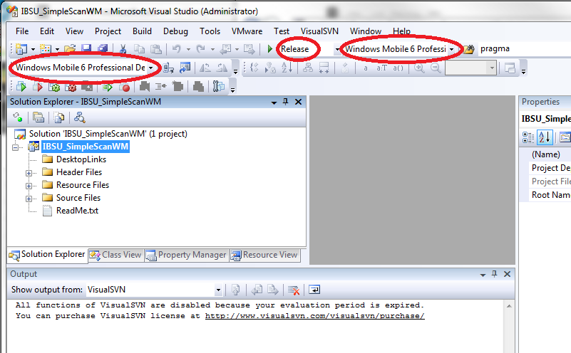Select “IBSU_SimpleScanWM.sln” and open it. Note: if you have not moved the SDK outside of Program Files then you will have needed to open Visual Studio with administrator privileges first.
5. Select whether you want build the release or debug version. Release is selected in the example above (middle red oval).
6. Select the configuration to build “Windows Mobile 6 Professional SDK (ARMV4I)” in the example above in the rightmost red oval.
7. If the application is deployed through visual studio then the oval on the left indicates the type of device it will be deployed to. In the example above “Windows Mobile 6 Professional Device” is selected. To deploy and run an application for use with an IB Scanner on the Intermec CN70 special hardware is required to connect the Colombo scanner while simultaneously supporting the USB function port for use with the “Windows Mobile Device Center”.

### Installing the IBScanUltimate Device Drivers and DLLs

The SDK includes the file IBSU_InstallDrivers.CAB. This cab file installs all of the drivers and DLLs necessary for an application built with this SDK to access the Integrated Biometrics scanner. All these files are installed to the Windows directory, which makes them available to all applications, no matter where the application is installed. So it is not necessary to install your application in the Windows directory.

The files installed are:

|  |  |
| --- | --- |
| Name | Description |
| CEUSBKWrapperDrv.dll | Kernel level portion of CEUSBKWrapper. |
| CEUSBKWrapper.dll | User level portion of CEUSBKWrapper. |
| Libusb-1.0.dll | Upper level USB Interface used by IBScanUltimate SDK. |
| IBScanUltimate_WM6.dll | IBScanUltimate SDK Dll |
| MFC90U.dll | Microsoft runtime library component |
| ATL90.dll | Microsoft runtime library component |
| MSVCR90.dll | Microsoft runtime library component |

This cab file also makes registry changes necessary to register the device driver with the Windows Mobile operating system. These changes can be seen by viewing the file IBSU_InstallDrivers.inf. The INF is not used for installation, it is simply provided for your reference.

Installing:

1. Copy <sdk location>\Driver\WM6\IBSU_InstallDrivers.CAB to the Windows Mobile device either using a SDCard or the Windows Mobile Device Center (Active Sync)
2. On the Windows Mobile device open file explorer
3. Navigate to the folder you stored IBSU_InstallDrivers.CAB
4. Click on IBSU_InstallDrivers.CAB
5. When prompted select install to “Device”
6. Click “Install”
7. You should see the message “IBSU_InstallDrivers.CAB was successfully installed on your device”
8. Click “OK”
9. Restart the device to load the device drivers

**Support Contact Information:**

[www.integratedbiometrics.com](http://www.integratedbiometrics.com)

**Integrated Biometrics, LLC**

